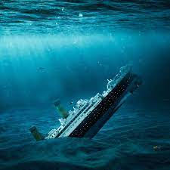

Re-engineer software to save the drowning ship

PRESENTATION REPORT TEMPLATE:

OBJECTIVE:

REAL WORLD SCENARIO RELEVANCE:

FACTS /CASE STUDY:

CONCLUSIONS: